Group 1 - Project Proposal
- Group number and names of all group members.
Group 1: Damian Mendoza, Ingri Quevedo, Stephanie Armstrong, Hassan Saleh H Alshamrani
- Assigned NoSQL database and its primary database model.
Apache CouchDB: a document database. Data is stored as JSON documents and accessed over HTTP/REST.
- Business problem, intended users, and why the problem is suitable for the assigned NoSQL platform.
Business Problem: ShopTrack is a simple order management system for a small online store. It tracks orders through four stages: processing, shipped, delivered, and cancelled.
The intended users are store managers, who monitor order status across the store, and customer support staff, who need to find a customer’s orders quickly and update them when something changes. CouchDB fits this scenario because each order is a self-contained record holding the customer, items, prices, address, and dates. CouchDB can store the whole order as a single JSON document and return it in one request by ID. The same data will also be loaded into MySQL so both databases can be compared on identical tasks.
- Dataset source, format, approximate size, and planned preparation/cleaning.
The dataset is synthetic (dummy) data. Its structure and product examples are based on a public sample orders dataset (JSONSift), and all orders were generated for practice, so there is no real customer data and no privacy concern. The data comes in two files containing the same orders: a JSON file for CouchDB (orders_500_couchdb.json) and a SQL file for MySQL (orders_500_mysql.sql). It includes 500 orders, 80 customer IDs, 8 products, and 1,520 order items across five cities (Austin, Boston, Chicago, San Francisco, and Seattle), with 125 orders in each status.
Key fields: id/_id, userId, status, items (sku, name, quantity, unitPrice), subtotal, tax, shipping, total, shippingAddress, createdAt, deliveredAt, currency, and dataOrigin.
Preparation: The files are already prepared. After import, the group will verify that both databases contain exactly 500 orders. The files will be imported once to avoid duplicates. The imports have not been tested yet.
- Preliminary NoSQL data model or structure.
CouchDB: One database with one document per order. The _id is the order number (e.g., syn_ord_0001). Items and the shipping address are embedded in the order document because they are always viewed together with it.
MySQL (for comparison): Two tables: i) orders has one row per order. ii) order_items has one row per item. The tables are linked by order ID (primary key/foreign key).
The model may be refined once implementation begins.
- Preliminary architecture/data-flow diagram.
Preliminary Data Model
- CouchDB: one database with one document per order. The items and the address are kept inside the order document, because they are always viewed together with the order.
- MySQL: two tables. The orders table has one row per order, and the order_items table has one row per item. The two tables are linked by the order ID (primary key and foreign key).
Architecture / Data Flow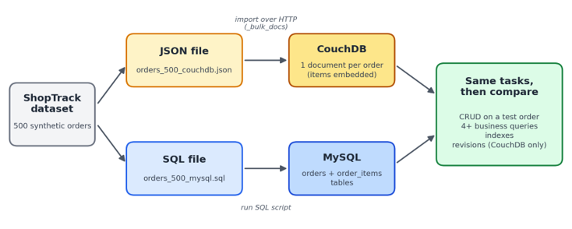
The ShopTrack dataset (500 synthetic orders) is split into a JSON file, imported into CouchDB over HTTP via _bulk_docs, and a SQL file, run as a script into MySQL. The same tasks are then run on both databases and compared: CRUD on a test order, 4+ business queries, indexes, and revisions (CouchDB only).
- Short preliminary comparison with MySQL: why might this scenario benefit from the assigned NoSQL database?
Topic | CouchDB | MySQL
How an order is stored | One JSON document with items inside | Split into orders and order_items tables
Getting a full order | One request by order ID | Join the two tables
Structure rules | Flexible; documents can differ | Fixed schema with keys
Handling changes | Each document has a revision number (_rev) | Transactions and locking
- CouchDB is expected to be simpler for saving and reading complete orders.
- MySQL is expected to be stronger for reports across many orders.
- The final recommendation will be made after testing.
- The final report will also compare CouchDB with MongoDB.
- Responsibility matrix showing each member’s primary responsibility.
Member | Main task (project work) | Presentation (slides) | Live demo
Hassan Saleh H Alshamrani | Business problem, dataset, architecture diagram; CouchDB technical research (HTTP/REST, security, deployment, licensing); MongoDB comparison | Introduction, business problem, dataset; CouchDB vs. MongoDB | Add a new order over HTTP and display it
Damian Mendoza | Install CouchDB & MySQL, import data, set up MySQL tables; MySQL comparison: relational mapping (tables, primary/foreign keys, joins vs. embedded documents) | Data model: CouchDB documents vs. MySQL tables | Show loaded data in both databases; run the business queries in MySQL
Ingri Quevedo | Update/delete operations; CouchDB revisions and replication concepts; MySQL comparison: concurrency, transactions, consistency | CouchDB features (revisions/MVCC) vs. MySQL transactions and locking | Update and delete an order; show how revisions prevent overwriting
Stephanie Armstrong | Business queries (Mango selectors) and indexes; MySQL comparison: querying and indexing, performance; final recommendation | Queries and indexes; final recommendation | Run the business queries and show the indexes in CouchDB
These responsibilities are subject to change. Every member will help with the whole project, understand all parts, and take part in the presentation and demo.
- At least two technical risks, setup questions, or issues the group expects to investigate.
Risks:
  - Installation problems: Members use different computers, so CouchDB and MySQL setup may not behave the same for everyone.
  - Import errors: Importing twice or into the wrong database could create duplicate or conflicting data. Mitigation: import once and verify the counts.
  - Learning CouchDB queries: Mango selectors and indexes are new to the group and may take extra time.
Questions for the instructor:
  - Should the MySQL design be fully normalized (e.g., add a products table), or is explaining that in the final report sufficient?
  - Is demonstrating document revisions acceptable as the CouchDB-specific feature, or would replication be preferred?

